34.116: a) Using the diagram and law of sines
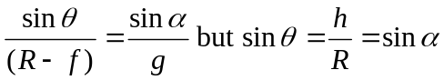(Reflection Rule).
So 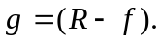
Bisecting the triangle: 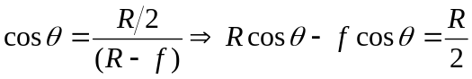
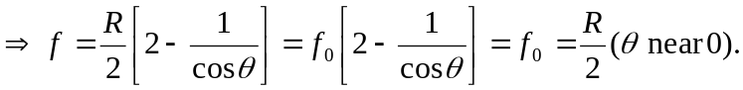
b)
